Part one: Measuring length

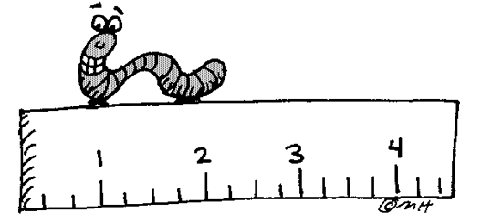
Expectations: Use either a meter stick or metric ruler to measure the following items in the classroom. You will work in lab groups, and do not have to do these in order. If you need to get up to measure something, please just let me know and I will allow you to do so.

1. Length of paper clip: __________ cm

2. Width of paper clip: ___________ mm

3. Width of classroom door: _____________ cm

4. Length of student desk: ______________ cm

5. Height of student desk: _____________ m

6. Length of science book: _____________ cm

7. Width of science book: _____________cm

8. Thickness of science book: ________________ cm

9. Length of new pencil eraser: ______________ mm

10. Thickness of pencil eraser: _______________mm

Closing Questions:

11. What was the longest thing you measured, and how long was it?

12. What was the shortest thing you measured, and how long was t?

